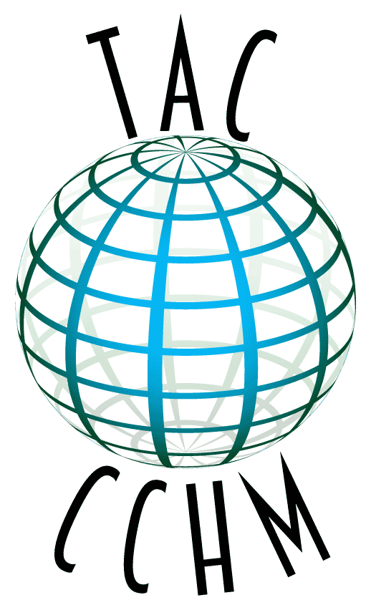

The Archaeology Channel
Conference on Cultural Heritage Media

Eugene, Oregon, USA
18-20 May 2023
ABSTRACT SUBMISSION FORM
ABOUT THE CONFERENCE
The Archaeology Channel Conference on Cultural Heritage Media, organized by Archaeological Legacy Institute (ALI), invites interested parties to gather for the discussion of audiovisual media in the study, preservation and promotion of cultural heritage. We wish to focus on topics of interest to cultural heritage professionals, media professionals and all those interested in applications of cultural heritage media. TAC Conference is held as a part of the twentieth annual edition of The Archaeology Channel International Film Festival, a juried competition in the cultural heritage film genre and a celebration of cultural heritage media.

A central activity at the Conference is the exchange of ideas through formal presentations, symposia and forums. We encourage participation in this manner from all quarters. The Conference is an opportunity for you to share your perspectives on the uses of audiovisual media for the study, preservation and promotion of cultural heritage. Your contribution will further the development of cultural heritage media as a strong and positive influence for people everywhere.

ABSTRACT FORMATS AND REQUIREMENTS
Abstracts must be 150 words or less, not including title, authors’ names, and affiliation(s). An abstract may be for one of three purposes or categories: (1) an individual contributed paper, (2) an organized symposium, or (3) a forum. The specifications for each are as follows:

✤ Individual Contributed Paper. A 30 minute oral presentation, including time for questions and answers. Individually submitted papers will be grouped into sessions organized by ALI around common themes.

✤ Organized Symposium. Submitted by an organizer on a specific topic, and including no more than eight 30 minute oral presentations. Total length 2-4 hours.

✤ Forum. Submitted by an organizer, a forum session has an interactive format organized around a tightly focused theme. A forum may have no fewer than three participants designated as discussants, with one moderator or two co-moderators and no more than 12 participants in discussant roles. No papers are involved for a forum.

All organizers and presenters, including co-authors, must have completed their Conference registration ($100) by the submission deadline. Co-authors who do not plan to attend do not need to register for the Conference.

Abstract Submission Deadline (and Conference registration deadline for presenters):
January 31, 2023

Conference Dates: May 18-20, 2023

ABSTRACT INFORMATION
Abstract Category:
- Individual Contributed Paper
- Organized Symposium
- Forum

Paper, Symposium or Forum Title: _________________________________________________
Presenter or Organizer: __________________________________________________________
Presenter or Organizer Affiliation(s): ________________________________________________
Secondary Author(s): ____________________________________________________________
Secondary Author’s(s’) Affiliation(s): _________________________________________________

Presenter or Organizer Address: __________________________________________________
City: ________________________ State/Province: ___________________________________
Zip/Country Code: ______________________ Country: _______________________________
Phone #1:_________________________ Phone #2: __________________________________
Fax:_________________________________ Email: __________________________________
Website: _____________________________________________________________________

Abstract (150 word limit; use attachment if necessary):

If submitting a Symposium or Forum proposal, please attach participant abstracts and information using the format above.

SEND HARD-COPY PROPOSALS TO
TAC Conference on Cultural Heritage Media
Archaeological Legacy Institute
4147 E. Amazon Drive
Eugene, Oregon 97405
USA

SEND ELECTRONIC PROPOSALS AND INQUIRIES TO
conference@archaeologychannel.org
Phone: 541-345-5538

